FD Chaplain Services, Inc.
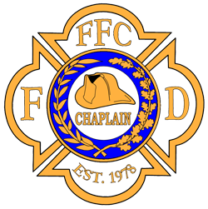
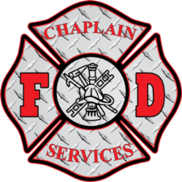
&
Federation of Fire Chaplains

Hosted by
Lebanon County Fire Chaplains Association
Berks County Fire Chaplains Network

PRESENT

“Essentials of Fire Chaplaincy”
Foundations of Fire Chaplaincy-Personhood of the Chaplain
Ministry to Firefighters- Crisis Victim Ministry-Chaplain Operations
CISM Basics- Peer Support Basics- Beginning a Fire Chaplaincy & Much More

Cost: $200 (includes FFC Basic Fire Chaplain Certificate @ USB FFC Training Manual)
Dates: August 3-4, 2022 (8:30am-5:30pm each day)
Location: Lebanon County Fire Training Center 833 Metro Drive, Lebanon, PA 17042

REGISTRATION FORM
PRINT OUT, Fill out and Scan/Email this form to ChaplainFD@gmail.com
(make checks payable to FD Chaplain Services)
Mailing address is 10221 S Golden Elm Dr. Estero, FL 33928

Name:_______________________________________
Address:__________________________________________________________________
Cell/Text#:________________________________
Email:____________________________________________
Agency/Department:_________________________________________ Occupation:__________________________ Chaplain at this time Y or N (circle one)
Will be paying for course on our website_____ Mailing Check_____ (check one)
If another person or agency is paying, please provide name_____________________

Instructor Mark Goodman is a veteran of the fire service with over 40 years’ experience as a Firefighter, Fire Inspector, Fire Marshal, and Fire Service Instructor III. He currently serves Estero FD, South Trail FD, San Carlos Park FD, Lehigh Acres FD, and Sanibel FD as Chaplain, and is a Peer Member of the Tri-County CISM Team. Mark is a Master Chaplain and Instructor III for the Federation of Fire Chaplains.

I understand and agree that if I decide to cancel my registration for this course, I must notify FD Chaplain Services, Inc. seven (7) calendar days prior to the first day of class in order to receive a refund. If a refund is approved, an administrative fee of $35 will be charged.
In the rare circumstance that FD Chaplain Services, Inc. must cancel a class, a full refund will be made.

