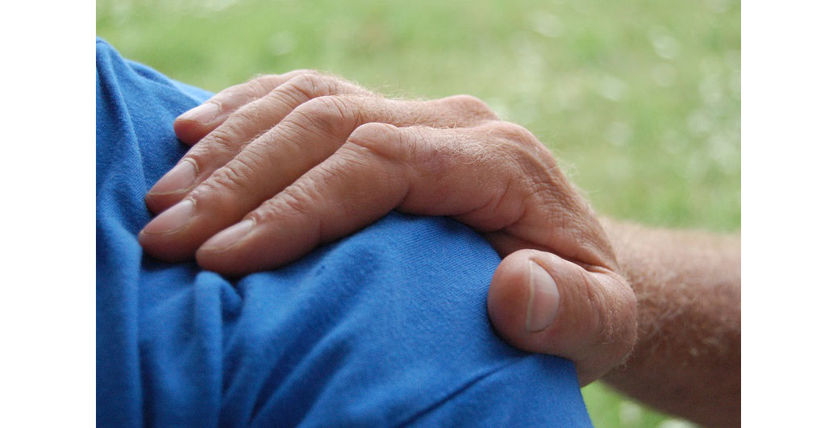

Why Every First Responder Department Should Have a Chaplain
By Rev. Peter Keady, Founder and President, First Responder Chaplain Corps,
with an introduction by Dr. Michael Pittaro, Associate Professor Criminal Justice at American Military University
I have known Peter Keady since we were in high school together and we have stayed in touch through social media and an occasional impromptu get-together. We recently had an opportunity to meet over coffee to discuss how our roles, although uniquely different at first glance, actually have more in common than we thought.
First responders serve, protect, and care for others, but they have not received the same attention and resources as those they serve, and this must change. We tend to forget that our mental wellness is just as important, if not more so, than our physical wellness.
First responders have exceptionally high rates of alcoholism, prescription drug abuse, divorce, and, most critically, suicide. I have worked hard to bring attention to these issues in the hopes of creating change to save lives. However, as a chaplain for First Responders, Peter Keady has ventured into an area that most of us, including myself, neglect to consider.
I am personally aware of the exceptional work that Peter has done, including his stellar reputation with the officers at two local police departments. With the success that he has had, I feel strongly that first responders should consider welcoming chaplains into their organizations because the benefits are endless.
I asked Peter to further explain why there is a need for chaplains to engage with first responders. In the words of Henry David Thoreau, “Not until we are lost do we begin to understand ourselves.” According to Peter, the stressors on first responders are unquestionably unique and today their needs are greater than ever. I’ll let him tell us more.
The behavioral health concerns for fire, police, EMS, dispatch, and correctional personnel have been significantly discussed and addressed over the years among scholars and practitioners alike.
Peer support, as well as mental health referrals, are readily available. These are good and necessary resources, yet the rates of divorce, suicide, and substance abuse for first responders continue to rise. Among the missing pieces in the complex puzzle of wellness and career longevity for first responders is the chaplain. But chaplaincy is more than a set of duties and not just any chaplain will do.

Role of a Chaplain to Provide Effective Support to First Responders
Traditionally, chaplains’ roles have been ceremonial; They are called upon for banquets, funerals, blessings, and weddings. They are well-meaning and primarily volunteer people of faith, having a heart and hand in assisting first responders and their local agencies.
But the days of the ceremonial chaplain are over if we genuinely want operational effectiveness. First responders need support in very specific ways. The unique and habitual stressors placed on them, along with critical incidents like officer-involved shootings, must be approached by properly trained chaplains because most first responders are hesitant about discussing personal concerns with so-called “outsiders.”
With the significant and ever-changing environment facing first responders, a new model of chaplaincy is essential. First responders need and deserve properly trained chaplains embedded in their departments, going beyond merely enthusiastic or sympathetic clergy occasionally appearing here and there.
Some departments have been blessed with such men and women. In understanding the holistic nature of people and the unique culture of first responders, these chaplains have taken the time to intentionally and properly be trained while connecting with agency personnel on an ongoing basis. They have truly become part of the life and culture of the department. This is an essential aspect of an effective chaplaincy program that cannot be over-emphasized.

Chaplains Focus on Relationships
The role of a chaplain is grounded in forming strong relationships with personnel. Chaplains must be preemptive and proactive, engaging with department personnel prior to critical incidents and providing first responders with empathetic support regarding their day-to-day stress. Creating a healthy relationship takes time and purpose.
Forming a relationship is key to gaining trust from first responders. Chaplains must make frequent visits to departments before first responders trust them enough to share stresses and strains. Weekly visits and ride-alongs are extremely valuable in building rapport and learning departmental culture. I haven’t met a responder who doesn’t like coffee, snacks or ice cream. I’ve spent time washing fire trucks, loading gear, and even purchasing bottled water for first responders.
Chaplains must always give far more than they receive. They must get his or her hands dirty serving first responders in order to gain trust.

Chaplains Must Be Properly Trained
No amount of “good will” or enthusiasm can substitute for a properly trained chaplain. They offer a Ministry of Presence, building familiarity and camaraderie with administration, command staff, and personnel. One of the unique and great strengths of a chaplain is resiliency before a critical incident occurs.
Chaplains, strategically trained and tactically placed, can be keys to improving wellness, work effectiveness, positive morale, and budgetary efficiency. Properly trained chaplains have an acute understanding of the culture of each branch of first responders; language, habits, needs, and stresses vary significantly among agencies. For example, dispatchers face an entirely different set of strain than a police officer so it’s essential to understand these differences.
Chaplains must be trained in Critical Incident Stress Management (CISM), suicide prevention and engagement, stress-reduction techniques, and Psychological First Aid. These training modules help bring continuity to chaplaincy as well as the insightful and empathic skills needed in working with first responders.
Chaplains are present in the heat of battle or for a cup of coffee at a local diner. They are available 24/7. The need for properly trained, embedded chaplains is greater than ever and should be considered as an addition to every department, fostering the greatest supportive environment for all first responders.
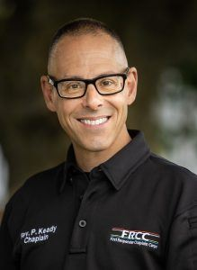About the Author: Reverend Peter Keady has been serving First Responder agencies for over six years. Having 20 years of pastoral ministry experience, he was presented with the opportunity of chaplaincy in serving his local fire department. Discontent with simply ceremonial duties, he sought additional training through the International Critical Incident Stress Foundation, The Federation of Fire Chaplains and the Police Chaplain Program, holding advanced certificates will all three organizations. He currently serves four local fire departments, two municipal police departments as well as the Pennsylvania State Police. He is a responding member of the Eastern Pennsylvania Regional CISM Team and recently founded the First Responder Chaplain Corps to, develop and support First Responder chaplaincies in agencies requesting them. He has multiple certifications in CISM, suicide engagement, First Responder trauma, disaster response and spiritual care.

