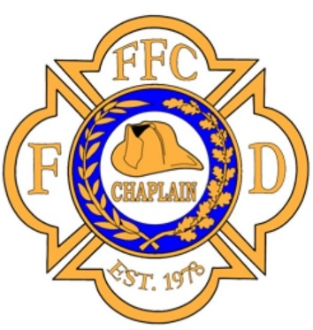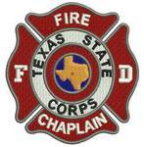
TEXAS CHAPLAIN TRAINING

Essentials of Fire Chaplaincy

May 14-15, 2021 (0800-1700)
Magnolia Fire Station 181
18215 Buddy Riley Blvd.
Magnolia, Texas 77354
Cost: $200.00 (includes manual on USB drive)

The "Essentials of Fire Chaplaincy" is a foundational training course for the fire department chaplain. This two day course is the basis for training recognition by the Federation of Fire Chaplains and earns the student a certificate from the FFC upon completion. U.S. Fire Departments are now using this FFC training as the standard for fire chaplaincy across the country, allowing chaplains to minister within the fire service wherever life takes them.

For additional information, class description, and registration, please go to the FFC Website: https://ffc.wildapricot.org/event-4139732

Class is limited to 20 students
Please register soon

