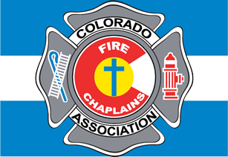  The Colorado Fire Chaplains Association in partnership with the Federation of Fire Chaplains presents:  Fire Chaplain training  August 28-29, 2020  Basic “Essentials” Fire Chaplain Certification  (mandated COVID safety measures will be in place)  Love firefighters? Love their families? How can you help Fire-Families build RESILIENCE and sustain HOPE?  Explore a calling to serve firefighter families  LEARN: Who is a Fire Chaplain  How to Serve Crisis Victims  Essentials of Fire Chaplaincy  How to Serve Fire-Fighters and Families  How to apply Pastoral Skills in Fire Culture  RECEIVE: Certificate  300-page Training Manual  Confidence to serve  Skills to serve well  In this two-day class: learn about fire-fighters, their families, their stressors, fire-culture and crisis victims. Learn to walk alongside these brave souls in a way that shows you care. Learn to love these heroes genuinely.  Register: FFC Fire Chaplain "Essentials" 8/28-29/2020  Lead Instructor, Paul Russell; Assistant, Ron Biegler  Class is authorized by the Federation of Fire Chaplains (FFC) for a certificate in “Basic Fire Chaplaincy.”  Visit www.firechaplains.org for FFC information and/or membership. | UNDERSTAND Fire-Fighters  Fire-Families  Fire-Culture  ────  Earn a Certificate in Basic Fire Chaplaincy  ────  HOPE & RESILIENCY to Fire-Fighters  ────  Only $250  Register at:  Chaplain Training  Lead Instructor  Paul (720) 220-5753  Assistant  Ron (720) 839-9537  Provided by:  Colorado Fire Chaplains Association  Apr 28-29, 2020 9:00 AM  Presented at:  Crosspoint Community Church  7076 S Alton Way #B  Centennial, CO 80112

