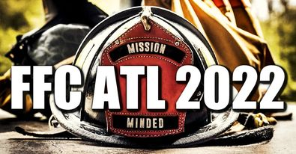

2022 FFC Annual Pre-Conference Schedule:
Saturday: 10/15
8:30 am – 5:00 pm-Pre-Conference Classes
Sunday: 10/16
8:00 am Church services Protestant and Catholic
9:00 am-5:00 pm-Pre-Conference Classes
6:00 pm Tired Travelers Reception
Monday: 10/17
8:00 am Devotional
9:00 am Opening Ceremony (Chaplain and Spouses)
9:30 am Keynote Speaker: Jim Duncan
Welcome to the Federation of Fire Chaplains
10:30 am Break
10:45 am Session 1 (Chaplain and Spouses separate)
Peer Counseling GA Dept of Public Safety Program-
Keegan Merritt
12:00 pm Lunch
1:30 pm Peer Counseling GA Dept of Public Safety Program-
Keegan Merritt (part 2)
2:45 pm Break
3:00 pm Session 2: Next Rung-Blake Stinnet
4:30 pm Free time
7:00 pm Celebration of life: Ed Stauffer
Tuesday: 10/18
8:00 am Devotion
8:30 am Session 3: Fire Service response to Trafficking-
JoAnn Sutherland
10:15 am Break
10:30 am Session 4 4heros-Frank Mercer
12:00 pm Lunch
1:30 pm Session 5 Regional Meeting
2:15 pm Session 6 Tools of the Trade
4:00 pm Dress for Memorial Service
5:00 pm Memorial Service
6:45 pm Evening Meal
Wednesday: 10/19
8:00 am Devotion
8:30 am Session 7 Reboot-JB Brown
10:30 am Break
10:45 am Surviving the Fire-LaGrange FF Survivors
12:00 pm Lunch/Silent Auction ends
1:30 pm Session 8 FORU/PACT-Ron J Little
3:00 pm Break
4:00 pm Dress for Founders Banquet, Awards, Live auction.
5:00 pm Founder’s Banquet, Awards, Live auction.
Thursday: 10/20
8:00 am Devotion
9:00 am FFC Annual Business Meeting

