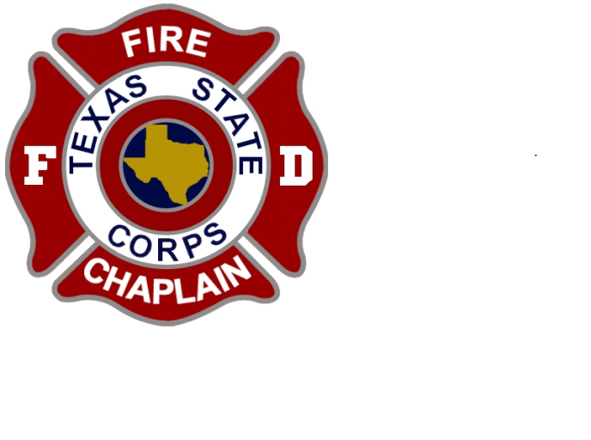

TEXAS CORPS OF FIRE CHAPLAINS
TRAINING CONFERENCE SOUTH

Date: August 23-24, 2019 Time: 8:00am-5:00pm
Place: Grace Chapel Church
31101 FM 2978
Magnolia, Texas 77354
Class: “Essentials of Fire Chaplaincy” (2-day class)
Cost: $200.00 (Includes FFC Manual)
Send Registrations To: Keith Smith - P.O. Box 1224, Euless, TX 76039
Or kwsmith46@sbcglobal. net
Payment: Check or Credit Card (call 817-480-5618 for CC payments)
Essentials of Fire Chaplaincy
This 2-day course, (accredited by the Federation of Fire Chaplains Institute), provides an opportunity for everyone–experienced chaplains, new chaplains, and prospective chaplains alike to learn valuable lessons about Fire Chaplaincy. Course content Includes: Foundations of Fire Chaplaincy, Personhood of the Fire Chaplain, Ministry to Firefighters, Ministry to Crisis Victims, Fire Chaplain Ops, & much more. (Completion of Essentials of Fire Chaplaincy is a prerequisite for any advanced class).
---------------------------------------------------------------------------------
Registration

NAME: _________________________________________________________________________
STREET ADDRESS: ______________________________________________________________
CITY:_______________________________ STATE: ____________ ZIP: ___________________
PHONE: _________________________________________________
EMAIL ADDRESS: _______________________________________________________________
Print and send with payment to the above PO Box or email address

