THE ESSENTIALS OF FIRE CHAPLAINCY COURSE

This course, created by the Federation of Fire Chaplains, provides an opportunity for everyone – experienced chaplains, new chaplains, and prospective chaplains alike – to learn valuable lessons about Fire Chaplaincy.

The class consists of 16 hours of instruction, over the course of two days, covering the following areas:

- The Foundations of Fire Chaplaincy
- Personhood of the Fire Chaplain
- Fire Chaplain’s Ministry to Firefighters
- Fire Chaplain’s Ministry to Crisis Victims
- Beginning a Fire Department Chaplaincy
- Critical Incident Stress Management
- Firefighter Injury or Death /
Death Notification
- Fire Department Funerals

CLASS SCHEDULE

Our class will meet on Friday and
Saturday, June 25 and 26, 2021, from 8:30 a.m. sharp to 5:00 p.m. You must be present for the entire 16 hours of instruction to receive Basic Fire Chaplain Certification.

COST

The Essentials of Fire Chaplaincy Course costs $225. This includes two days of instruction and discussion, Chaplain Manual from the Federation of Fire Chaplains.

LOCATION

Class will be held at the
Bullskin Twp. Fire Department
260 Keefer Road
Connellsville, PA 15425
724-887-0470

Dress is casual.

Lodging
Comfort Inn
325 North First Street
Connellsville, PA 15425

Holiday Inn Express
250 Bessemer RD
MT. Pleasant, PA 15666

Church/synagogue/mosque you attend:

Denomination (if any):

Are you an ordained/licensed clergyperson?
□ Yes □ No Fire department:

Are you currently appointed as a fire
chaplain? □ Yes □ No

Are you a trained fire fighter (FF 1 or
above)? □ Yes □ No

COST
Course Fee $225.00

Please mail this completed form and your check to:
Federation of Fire Chaplains c/o John F. Long, Jr
343 Cool Breeze Court
Pasadena, MD 21122

REGISTRATION
Mail this form, together with a nonrefundable registration fee of $225
(make your check payable to
“Federation of Fire Chaplains”) must be received no later than
June 6, 2021

Please print legibly

Your Name:

Mailing address:

Daytime phone number:

Evening or cell phone number:

E-mail address

Continued on reverse

YOUR INSTRUCTORS

Rev. John F. Long, Jr. is the Vice-President for the Federation of Fire Chaplains. He presently serves as the Chief Chaplain to the Maryland
State Firemen’s Association, Chaplain to the Anne Arundel County Volunteer
Firefighters Association, Chaplain to the National Volunteer Fire Council. He also serves on the National Fallen Firefighters Foundation Maryland L.A.S.T. team. John is a Nationally certified Fire Officer III, and Fire Instructor III. He has served in all fire line officers positions including three years as a Volunteer Chief. Certified in Spiritual Care in Crisis Intervention through the ICISF.

Gary White is currently serving as the Region Two Chaplain for the Maryland Fire Chiefs Association and as the Chaplain for the New Market District Volunteer Fire Rescue Department. He received his BS from Liberty University in Religion, an Advance Diploma in Biblical Counseling from Light University and holds his Advanced Fire Chaplain Certificate with the Federation of Fire Chaplains. He is currently a Board Certified Biblical Counselor with the International Board of Christian Counselors and a Board Certified Response Chaplain by the Board of Christian Crisis and Trauma Response.

ESSENTAILS IN
FIRE CHAPLAINCY
TRAINING
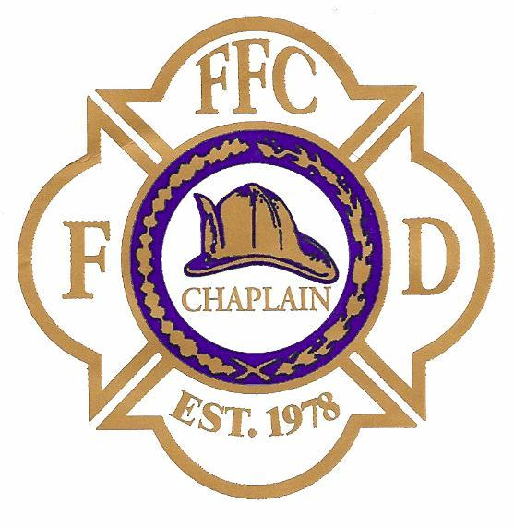
THE TOOLS YOU
NEED TO SERVE
THOSE WHO SERVE
OTHERS

June 25-26, 2021
Connellsville, PA
Sponsored by
The Federation of Fire Chaplains (www.FireChaplains.org)
And the
Bullskin Twp. Fire Department

