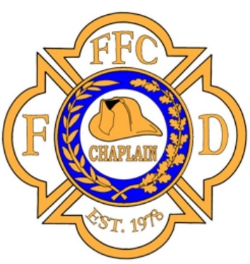
ARKANSAS CHAPLAIN TRAINING

Essentials of Fire Chaplaincy

JULY 16-17, 2021 (0800-1700)
At the Court Annex
1400 Highway 65 South
Clinton, Arkansas
Cost: $200.00 (includes manual on USB drive)

The "Essentials of Fire Chaplaincy" is a foundational training course for the fire department chaplain. This two-day course is the basis for training recognition by the Federation of Fire Chaplains and earns the student a certificate from the FFC upon completion. U.S. Fire Departments are now using this FFC training as the standard for fire chaplaincy across the country, allowing chaplains to minister within the fire service wherever life takes them.
Host Chaplain: Steve Bannick 870-504-2255
For additional information, class description, and registration, please go to the FFC Website:
http://www.firechaplains.org
or follow link below
http://www.ffc.wildapricot.org/event-4380396

Class is limited to 20 students
Please register soon

